How to Make Your Personal Legend of Becoming a Zoologist a Reality
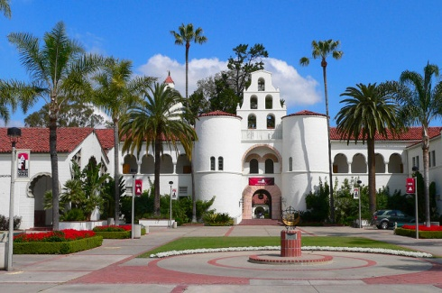
Education necessary to become a Zoologist:
- Since getting a degree in Zoology will limit your career options, we recommend that you major in Biology. You need a Bachelor's degree and at least 4 years of experience in that field to become a Zoologist.
- A Bachelor's degree in Zoology or Biology takes about 4-5 years of school at a university or college.
San Diego State University
- A Master's degree in Zoology takes 2-3 years of school after college.
- A Ph.D. in Zoology requires 2-6 years of school.
Salary/benefit information for a career in zoology:
- The median salary for a Zoologist is $47,740. The average starting salary depends on education and experience. Some Zoologists begin with a salary as low as $25,000 a year. The highest average amount of money that a Zoologist can make is estimated at about $71,000 a year.
- The projected growth of salary over time is between $15,202- $29,043 over a year 5 period. A Zoologist with a Ph.D. can make $100,000 a year.
- Medical and dental benefits
- With a degree in Biology or Zoology you could work as a zoo keeper, wildlife educator, researcher or a wildlife rehabilitator.
Housing:
- Rent will cost at least $750- $850 a month.
- Eventually, if you want to buy a house, your best bet is to buy a condo or a townhome. The median cost of a 2 bedroom, 2 bathroom condo in central San Diego is $299,000.
- Since zoologists make very little at the start of their careers, your best bet is to rent an apartment in San Diego.
- If you chose to live further inland, $299,000 could buy you a single family home. You can afford to live in Mira Mar, Paradise Hills, or Teralta West.

Total housing expenses in San Diego includes:
- Insurance cost approximately $1,200 a month.
- Average costs of utilities is around $300-$400/month.
- Maintenance varies from $200-$300 a month.
- Water, sewer & trash collection depends on the location you are living in, but the average cost is about $100 a month.
- Food is abundant and cheap. Having fresh fruits and vegetables year round, at very good prices since most of it is grown in California or nearby Mexico. You will probably spend $250-$750 on food a month.
- You will probably spend $1,000-$2,000 on clothing a year, and $800-$2,000 a year on entertainment.
Monthly Transportation Expenses:
- Median cost of a car payment is $380-$460 per month.
- Registration, gas and insurance will cost at least $2,000-$3,000 a year.
- When you are first beginning your career, you can save a lot of money by taking public transportation.
- Bus/ Trolley pass $72 a month
Summary:
You will want to try and get as much experience as you can with working with animals. Being in college to receive your Bachelor’s, Master’s and Ph.D. degrees will surely be a challenge that I’m sure you will be able to achieve. Becoming a Zoologist will be really rewarding and fun because you get to be around animals. Your yearly paycheck will help you pay off your expenses. Picking your house will be very exciting, but it will also be a hard decision because of the area and the cost. Transportation by bus or carpooling will be easy, because you save money by doing that. When you get your own car, the average amount of money you will spend on gas yearly is going to be $1,000-$3,000 depending on what kind of car you own. Since getting a degree in Zoology will limit your career options, having a Biology degree will allow you to work in the same branch as a Zoologist by becoming zoo keeper, wildlife educator, researcher or a wildlife rehabilitator. With the passion you have towards animals you will be able to accomplish any of these wonderful jobs.

